**How To Install Abaqus 2019 in Microsoft Window 10**

**Note: It is mandatory to install the Abaqus 2019 documentation and software in the given preference.**

* **Abaqus Simulation Services**
* **Abaqus Simulation Services CAA API**
* **Abaqus /CAE**
* **fr –safe**
* **Tosca**
* **Isight**

**The Abaqus 2019 software and documentation is zipped and available for download from CC ftp site. And Extract the Zipped file to local drive.**

1. **Go to Abaqus Documentation folder and run the setup.exe and click on next Button.**

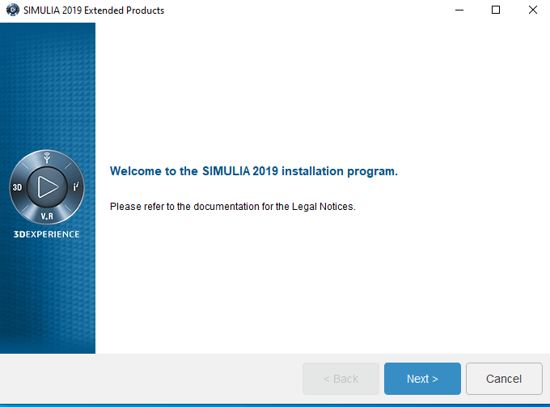

1. **Continue with the following selected products and click on “Next” Button.**

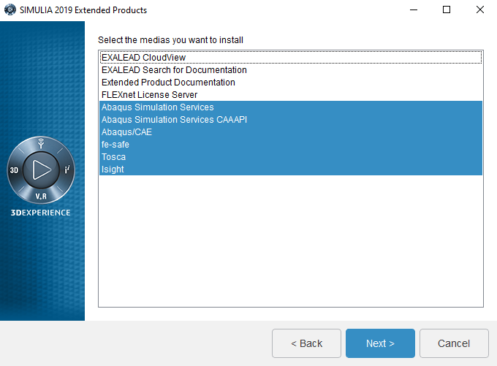

1. **Click on “Install” button.**

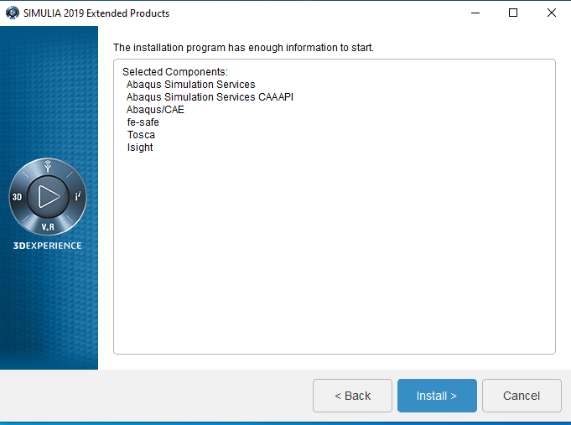

1. **Click on “Next” button for “Abaqus Simulation Services” Installation.**

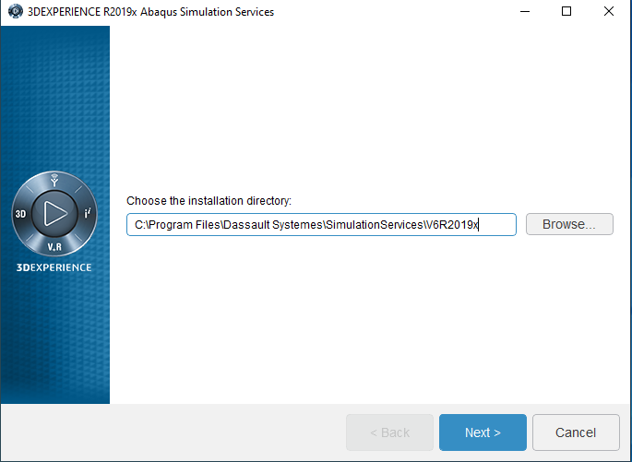

1. **Click on “Next” button.**

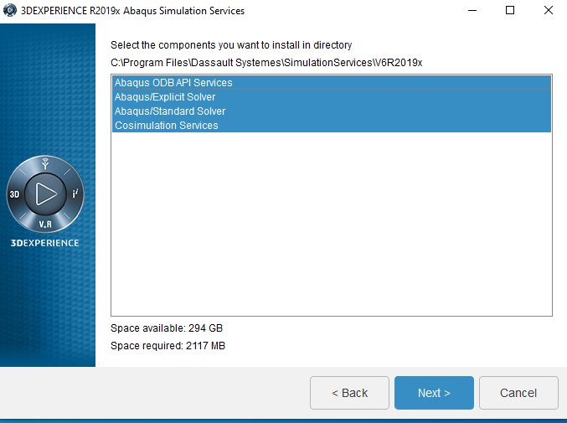

1. **Click on “Install” button.**

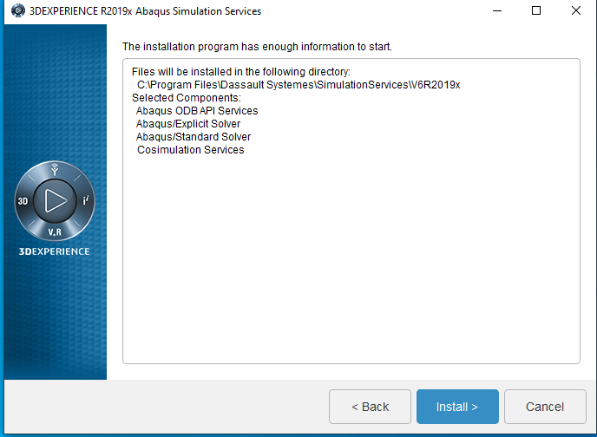

1. **Abaqus Simulation Service installation wait few minute**

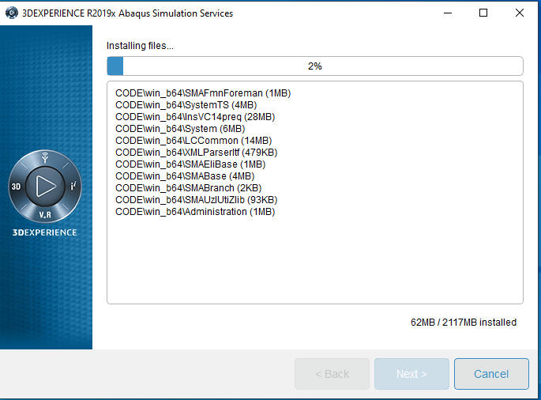

1. **Click on “Close” button.**

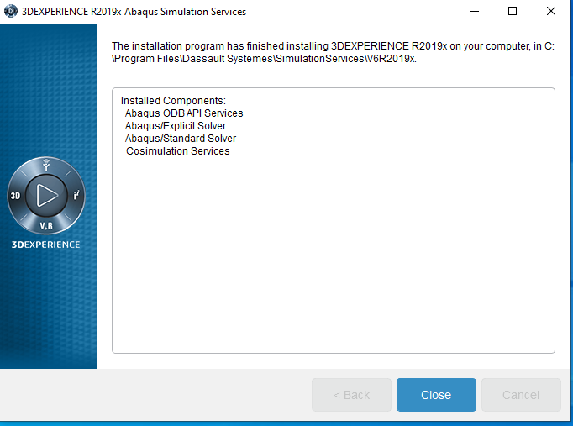

1. **Click on “Next button for “CAA API Abaqus Simulation Services” installation.**

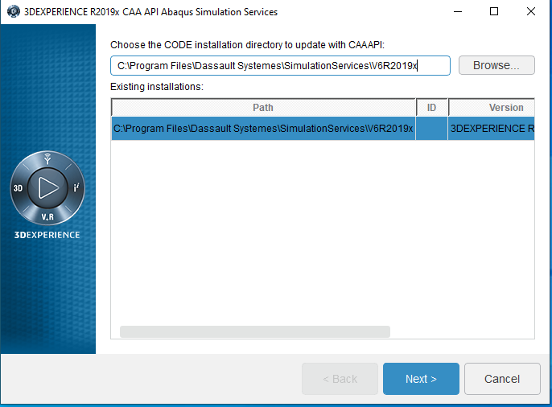

1. **Click on “Next” Button.**

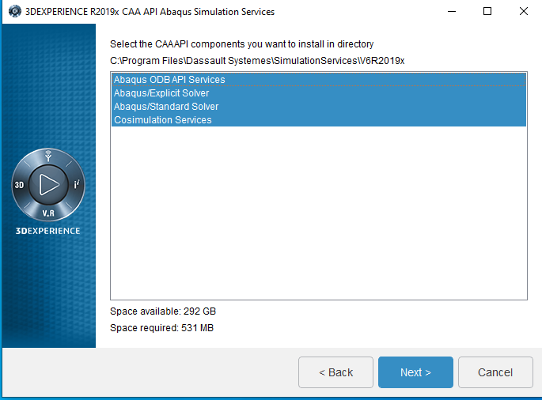

1. **Click on “install” button.**

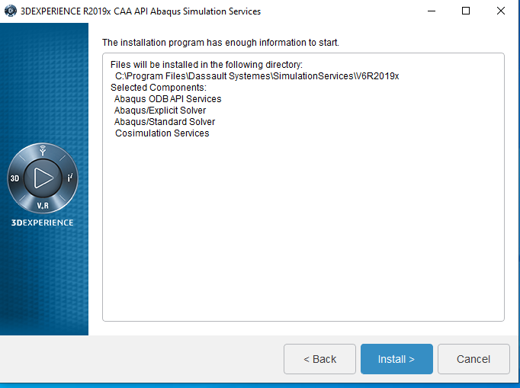

1. **“CAA API Abaqus Simulation Services” Installation process running**

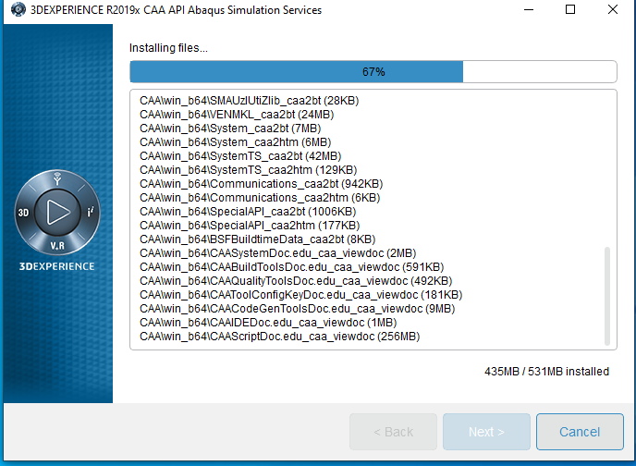

1. **Click on “Close” button.**

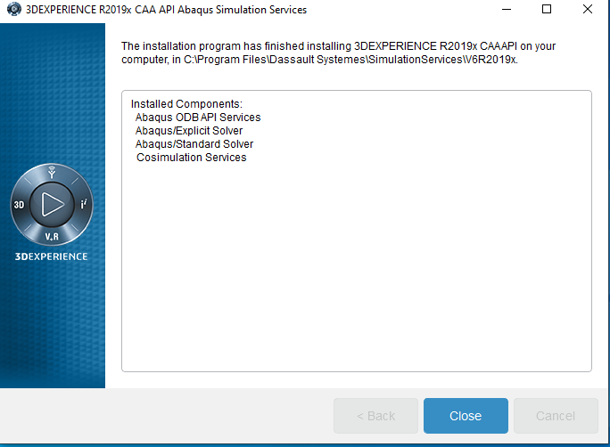

1. **Click on “Next” button for “Abaqus CAE “ Installation.**

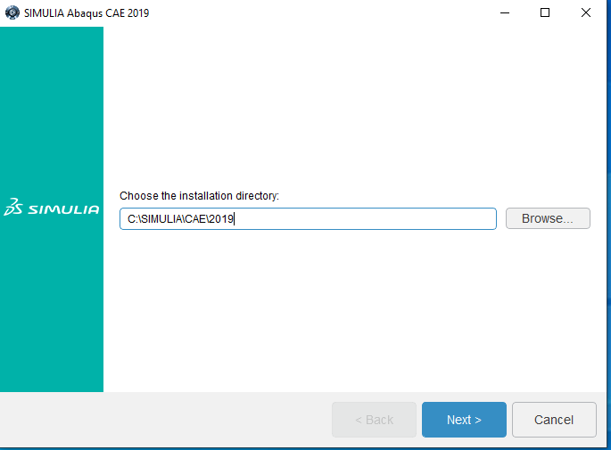

1. **Select “SIMULA FLEXnet” and Click on “Next” button.**

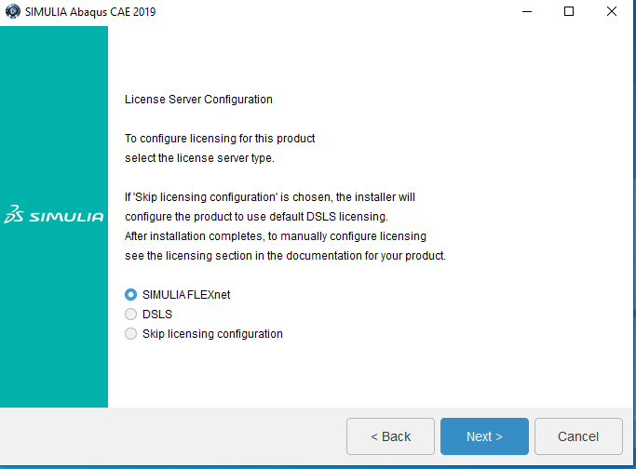

1. **Enter the licence server 1 (licence server is:29000@akash3.cc.iitk.ac.in) and click on “Next” Button.**

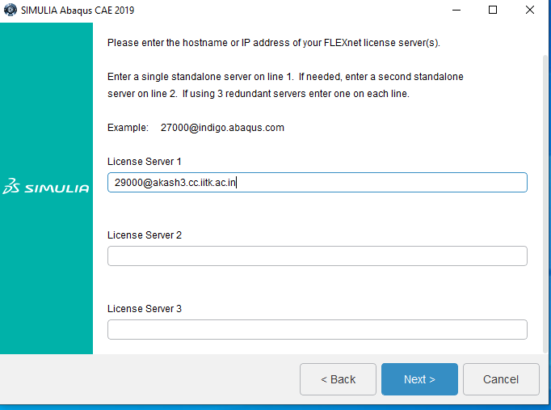

1. **Click on “Next” button.**

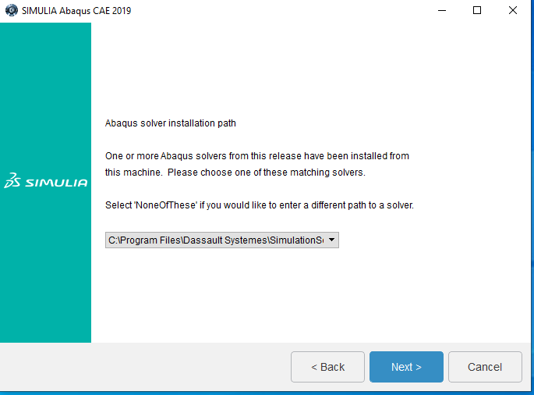

1. **Click on “Next” button.**

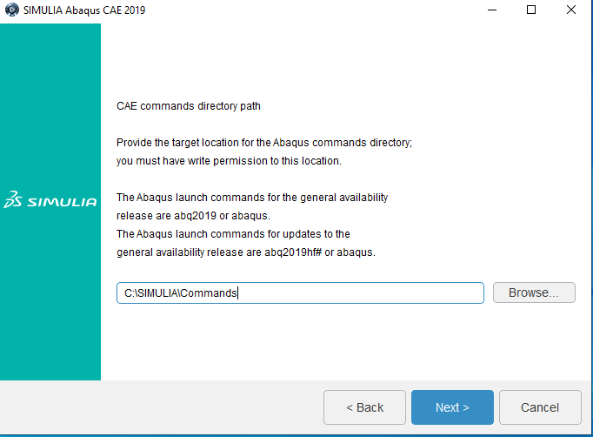

1. **Click on “Next” button.**

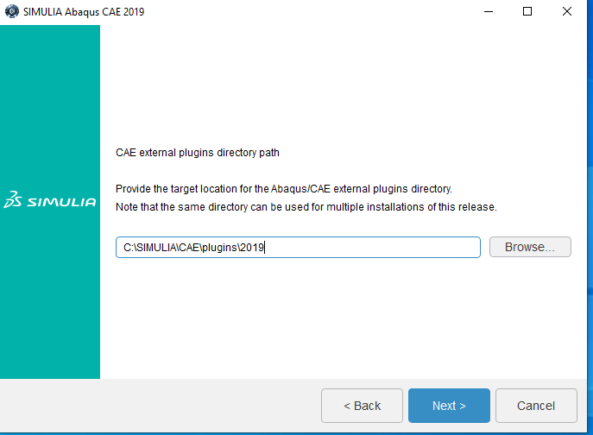

1. **Click on “Next” button.**

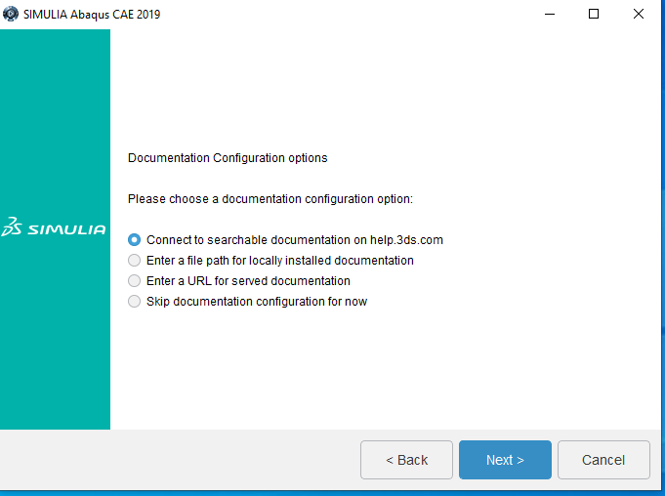

1. **Click on “Next” button.**

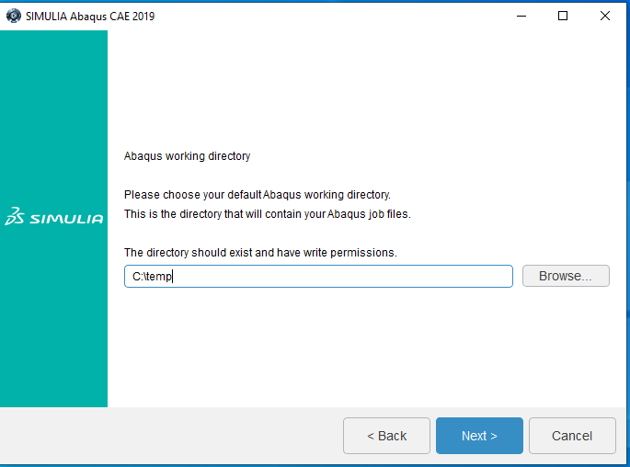

1. **Click on “install” option.**

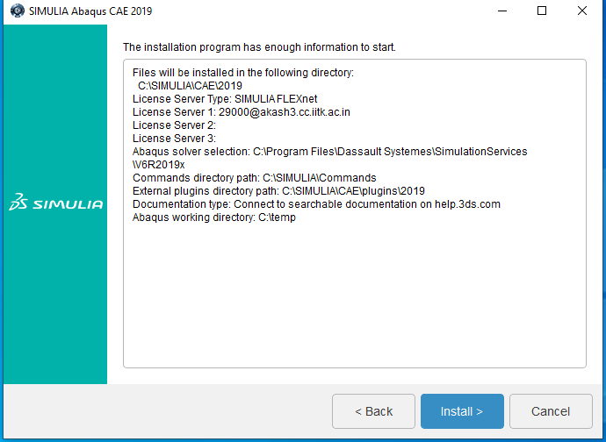

1. **SIMULA Abaqus Cae Installing process running**

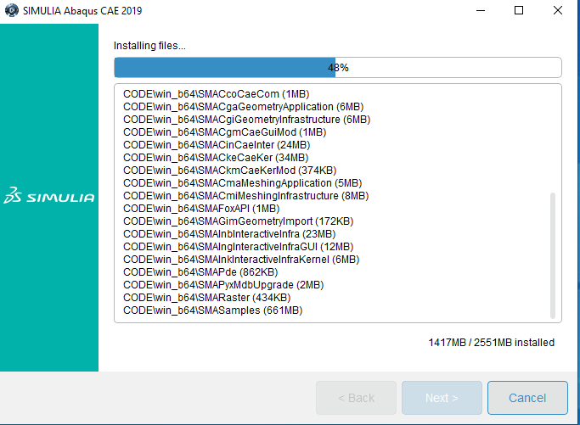

1. **After installation then click “Close” button.**

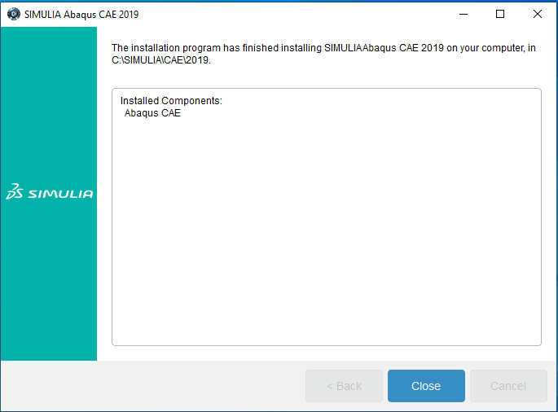

1. **Click on “Next” button for “fe –safe 2019” installation.**

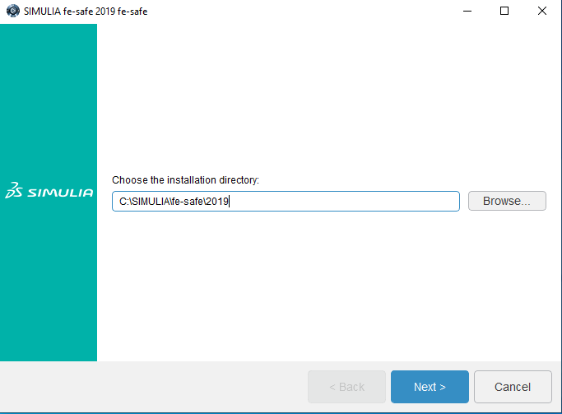

1. **Continue with the default selection and click on “Next” button.**

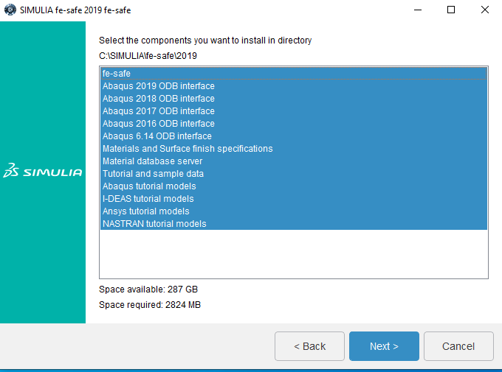

1. **Click on “Install” Option.**

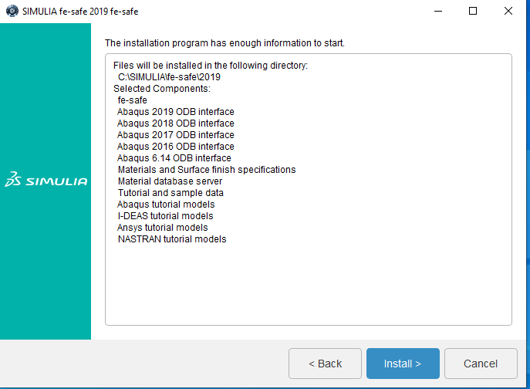

1. **“SIMULIA fe-safe” installation process running. Wait a few minute.**

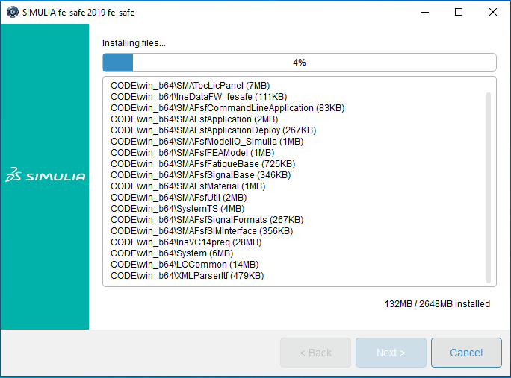

1. **Click on “Close” button.**

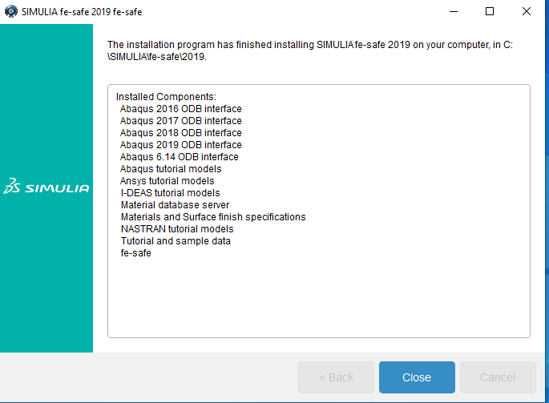

1. **Now we Install “SIMULIA TOSCA 2019” . Click on “next” button.**

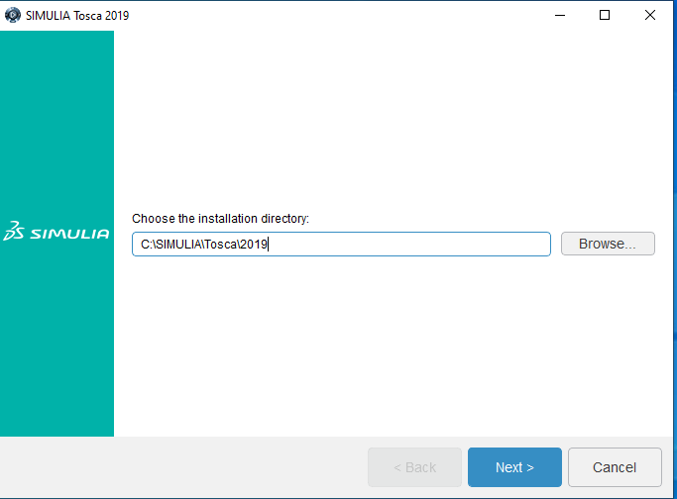

1. **Select “Skip documentation configuration for now” option and click on “Next” button.**

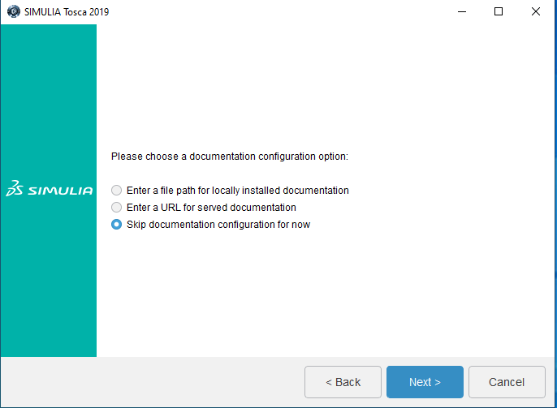

1. **Selected the Components you want to install in directory. We selected both tosca Fluid and Tosca Structure . Click on “Next” button.**

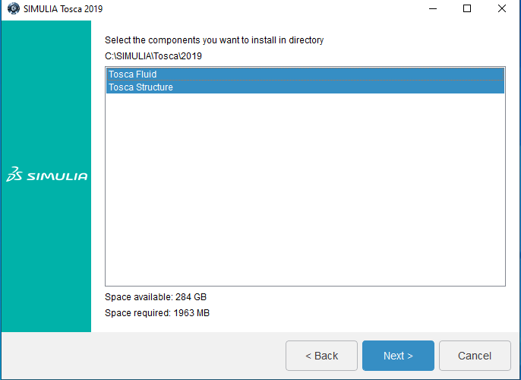

1. **Click on “Next” button.**

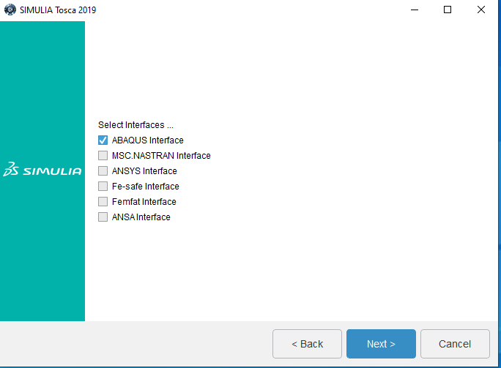

1. **Click on “Next” button.**

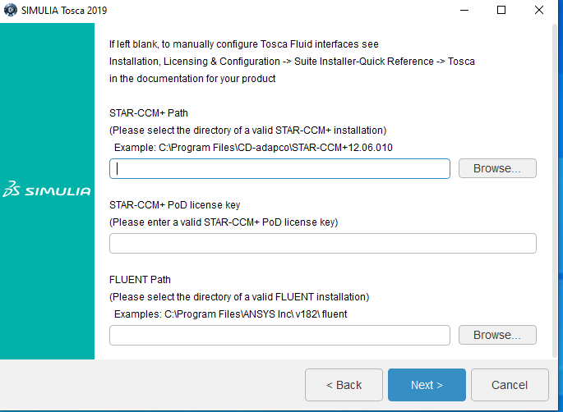

1. **Click on “Install” button.**

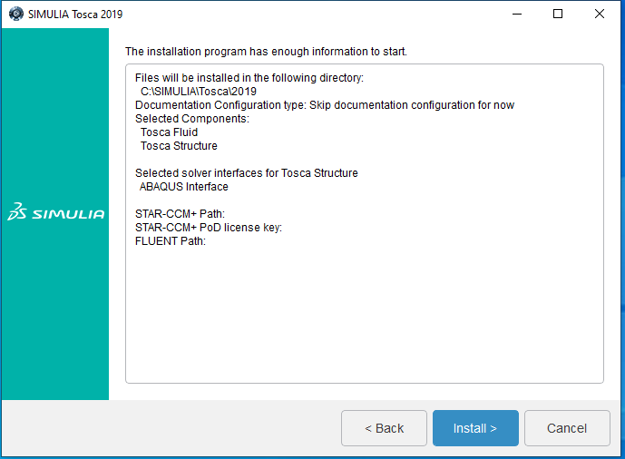

1. **The Installation process “SIMULIA Tosca 2019” is running.**

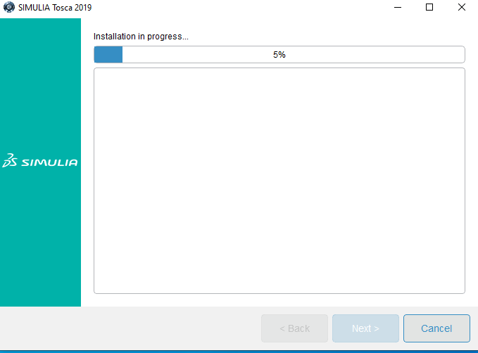

1. **“SIMULIA Tosca 2019” installation process has finished and click on “Close” button.**

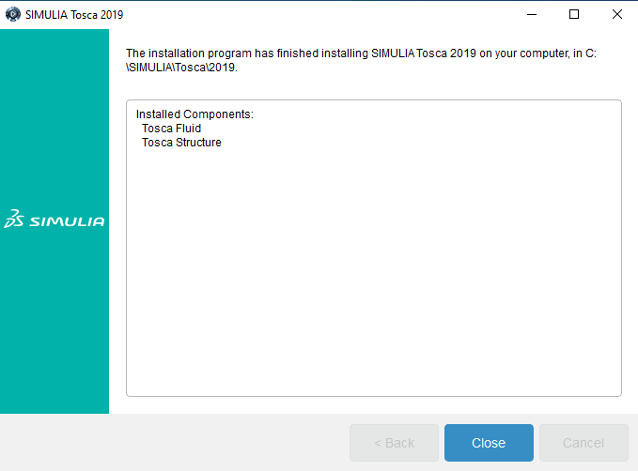

1. **Now Install “Isight 2019”. Click on “Next” button.**

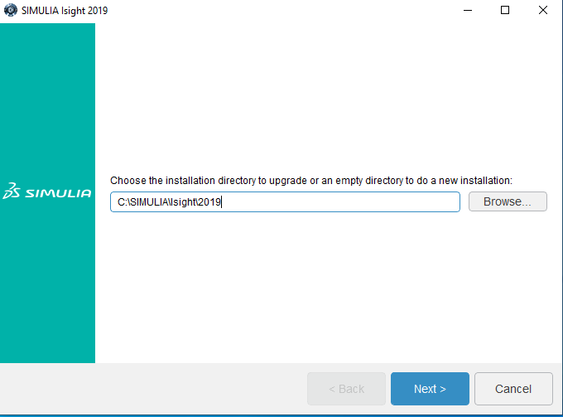

1. **Select the components you want to install. Click on “Next” button.**

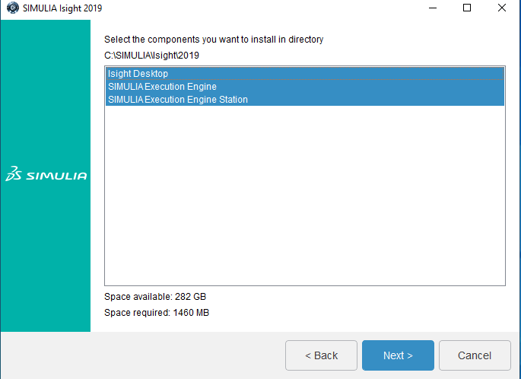

1. **Click on “Next” button.**

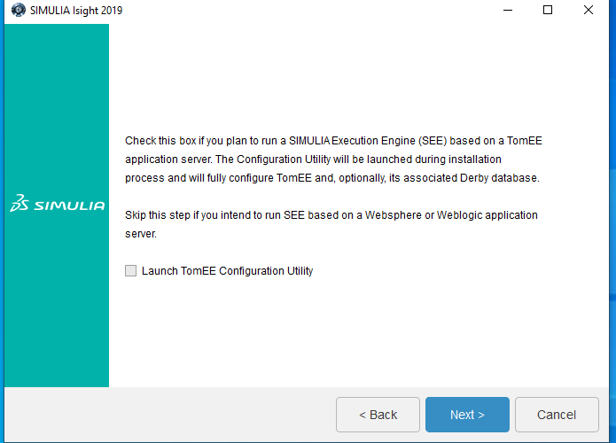

1. **Click on “Next” button.**

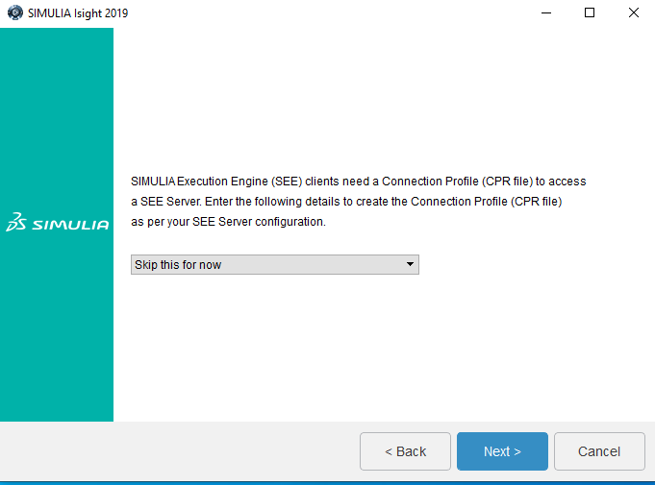

1. **Select “Skip documentation configuration for now” and click “Next” button.**

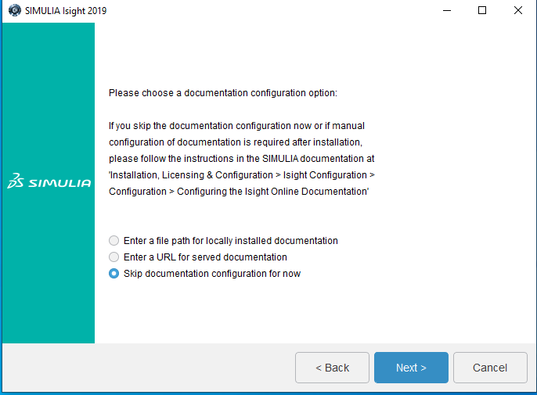

1. **Click on “Install” button to install “SIMULIA Isight 2019”**

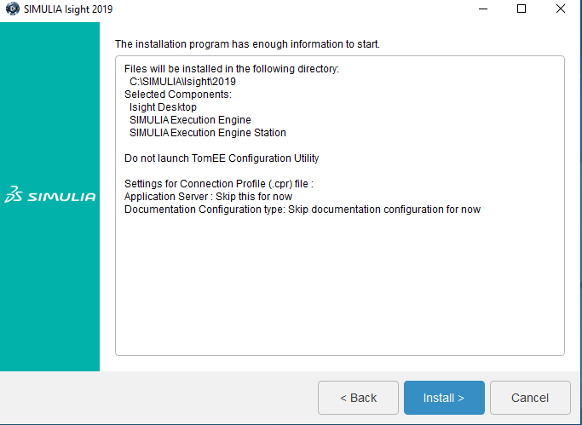

1. **Installation Process Running “ SIMULIA Isight 2019”.**

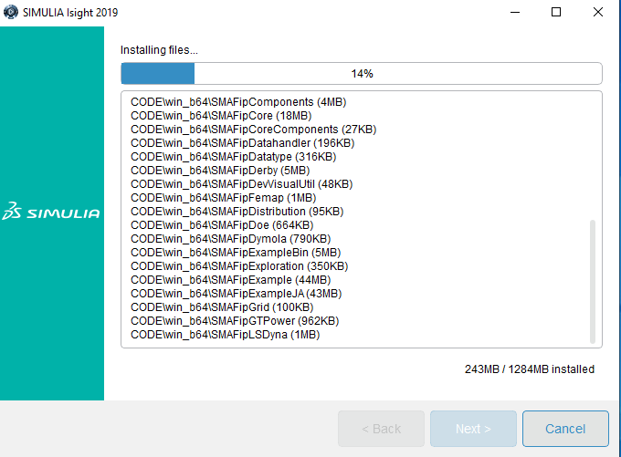

1. **SIMULIA Installation has finish and Click on “Close” button.**

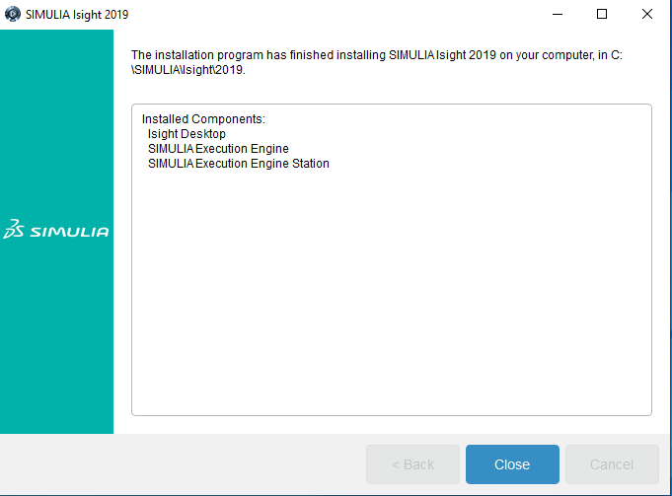

1. **All media are successfully installed . Click on “Close” button.**

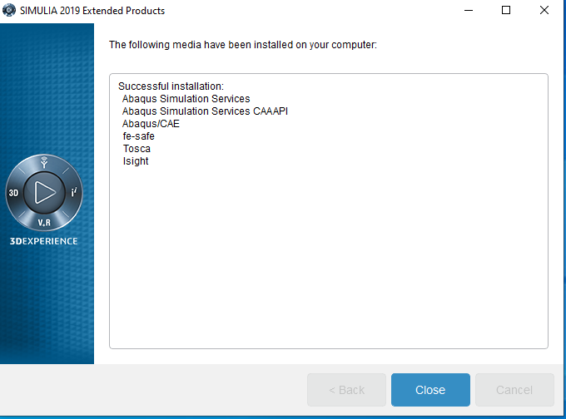

1. **Preview of the Software is:**

